February 14, 2021

Name: Dony Pierre
Assignment Week 5: Assignment – greetme
Course Name: SDEV-415-81: Linux/ Unix Programming I -
What was the first line of your script? Why do you need this line?
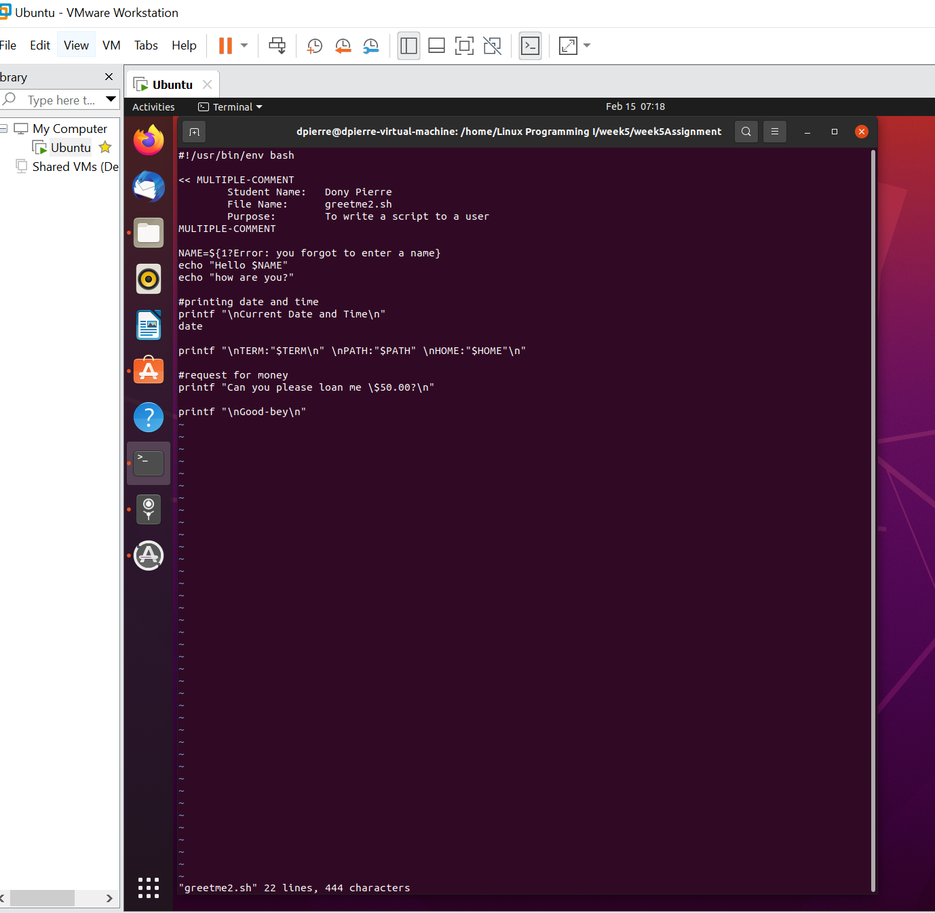
The first line that a BASH script needs is the proverbial 'shebang'. These are two characters:
#! it finds the bash program on my computer.
In any linux system it will find the bash program.




